Restoring DBA_Maintenance Database from the Template Using SSMS 2012

Login to the Remote Server as bcc\Database and startup SQL Server Management Studio 2012

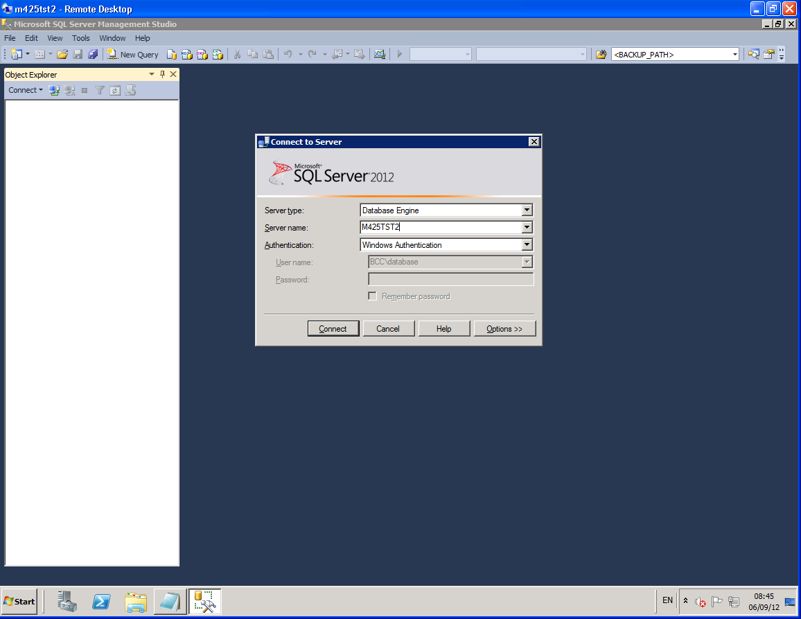

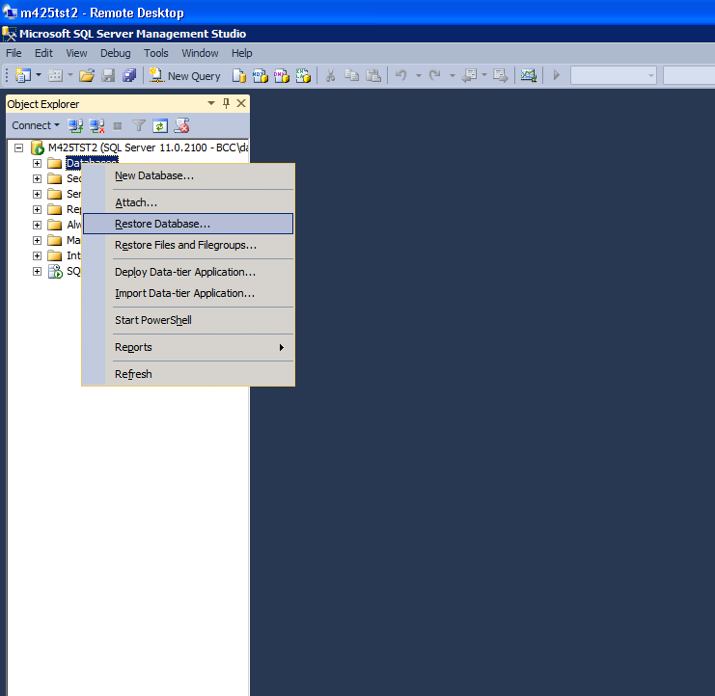
Right Click on Database and select Restore Database.

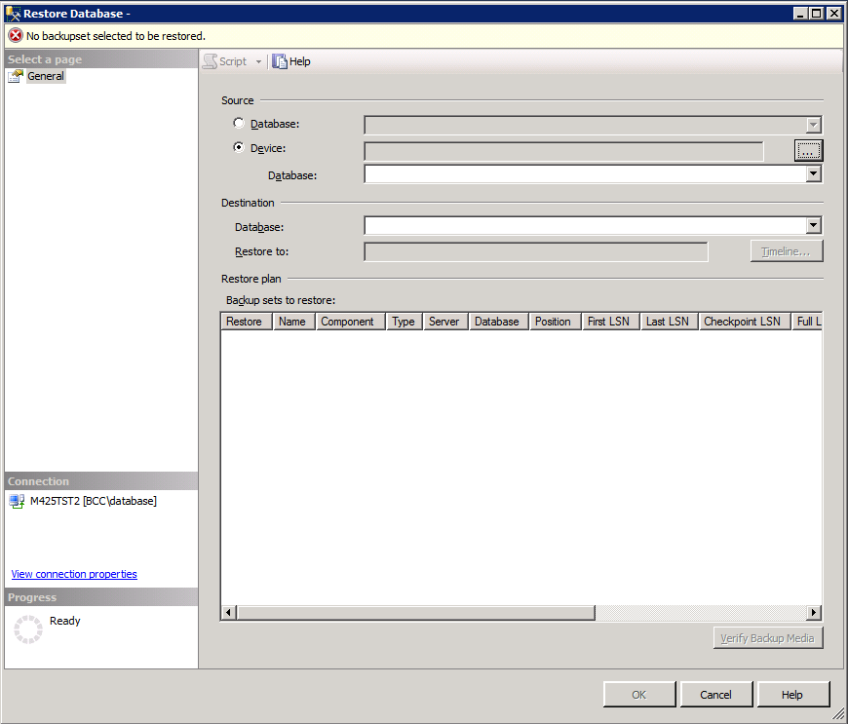
Select the Source: Device radio button and click the ellipsis to the right of this field.

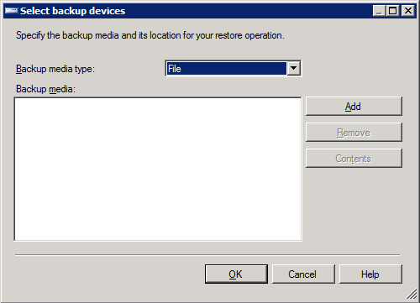
Click the Add button

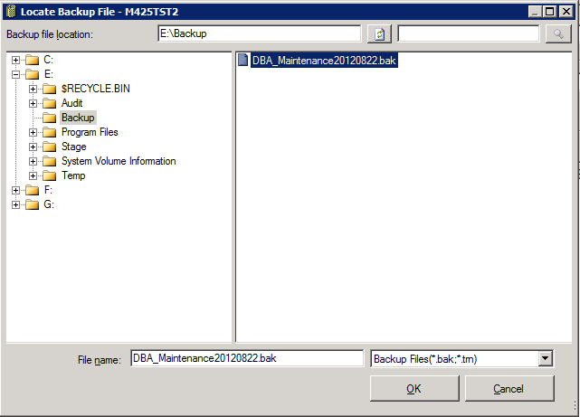
Locate and highlight the backup file and click OK.

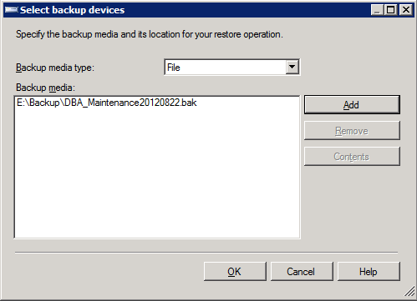
Click OK

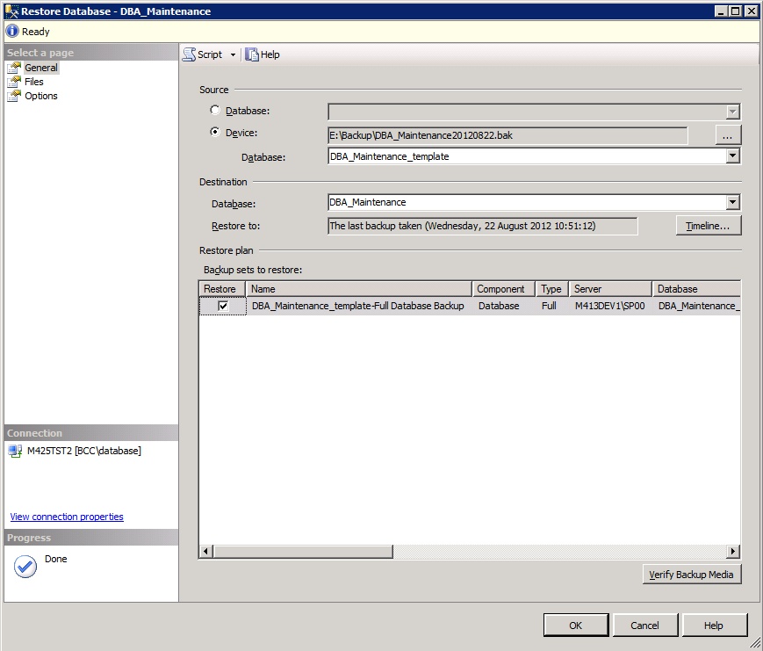
Change the value in the Destination: Database field to DBA_Maintenance and select Files from the Select A Page

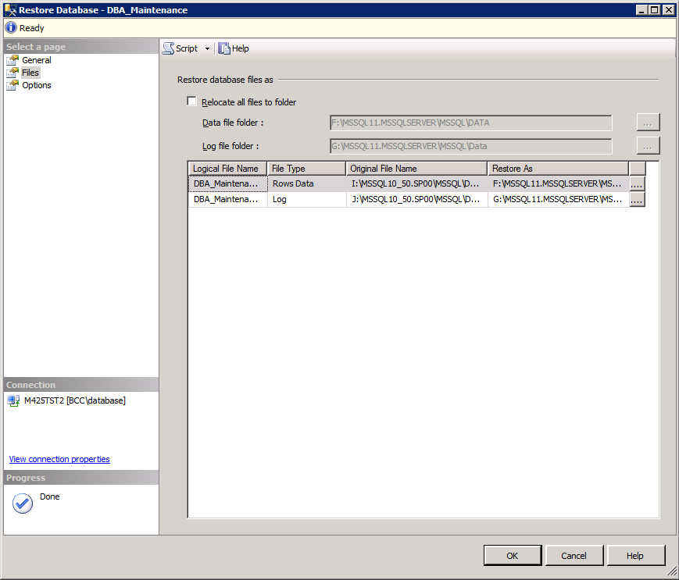
Confirm that the Restore As file locations are correct and select Options from Select A Page

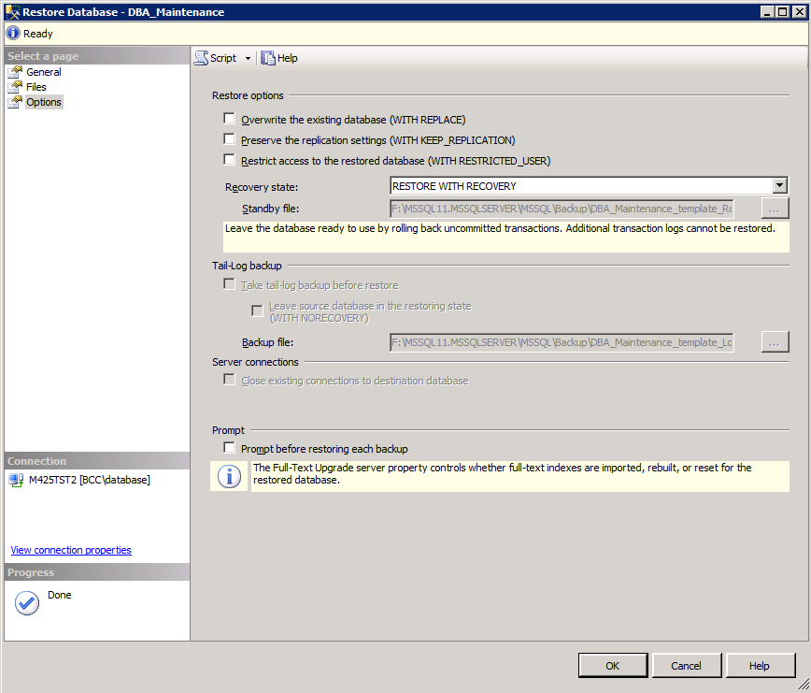
Confirm that the Recovery State is RESTORE WITH RECOVERY and click OK to restore the database.

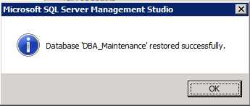
Click OK once the restore is complete.

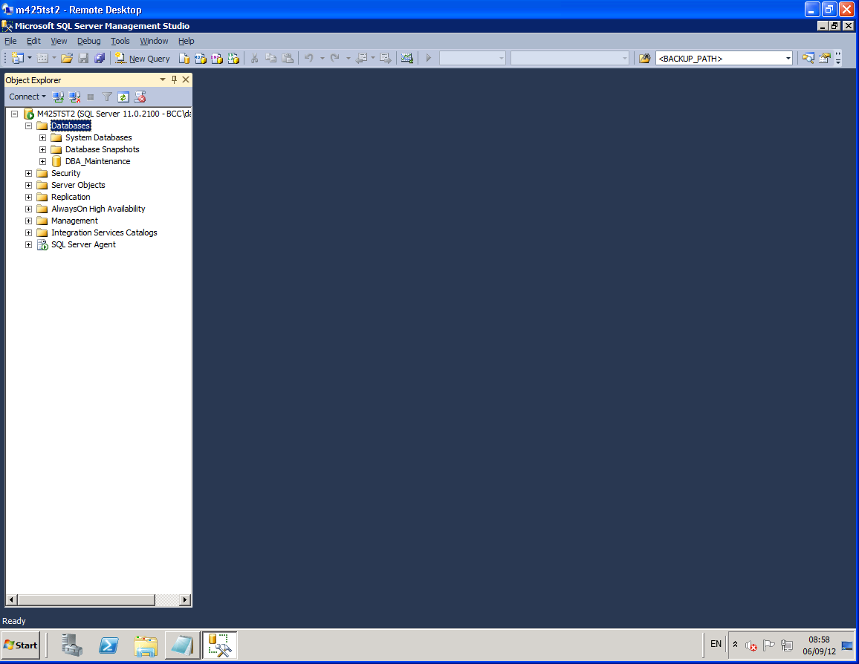
Confirm DBA_Maintenance Database was created by refreshing the object explorer in SSMS.

